**RedeemRewards Project( Selenium-TestNG Framework)**

**Overview**  
  
A framework based on Page Object Model, Selenium, TestNG, Gradle using Java.

This framework is based in **Page Object Model (POM).**

The framework uses:

1. Java
2. Selenium
3. Rest Assured( To test API’s)
4. TestNG
5. Gradle
6. ExtentReport
7. Log4j
8. SimpleJavaMail

**Pre- Requisites:**  
  
1. Java

2. Eclipse

3. All the other usages will be handled by build.gradle dependencies

**Path For TestCases**

**/lib/src/test/java/tests  
  
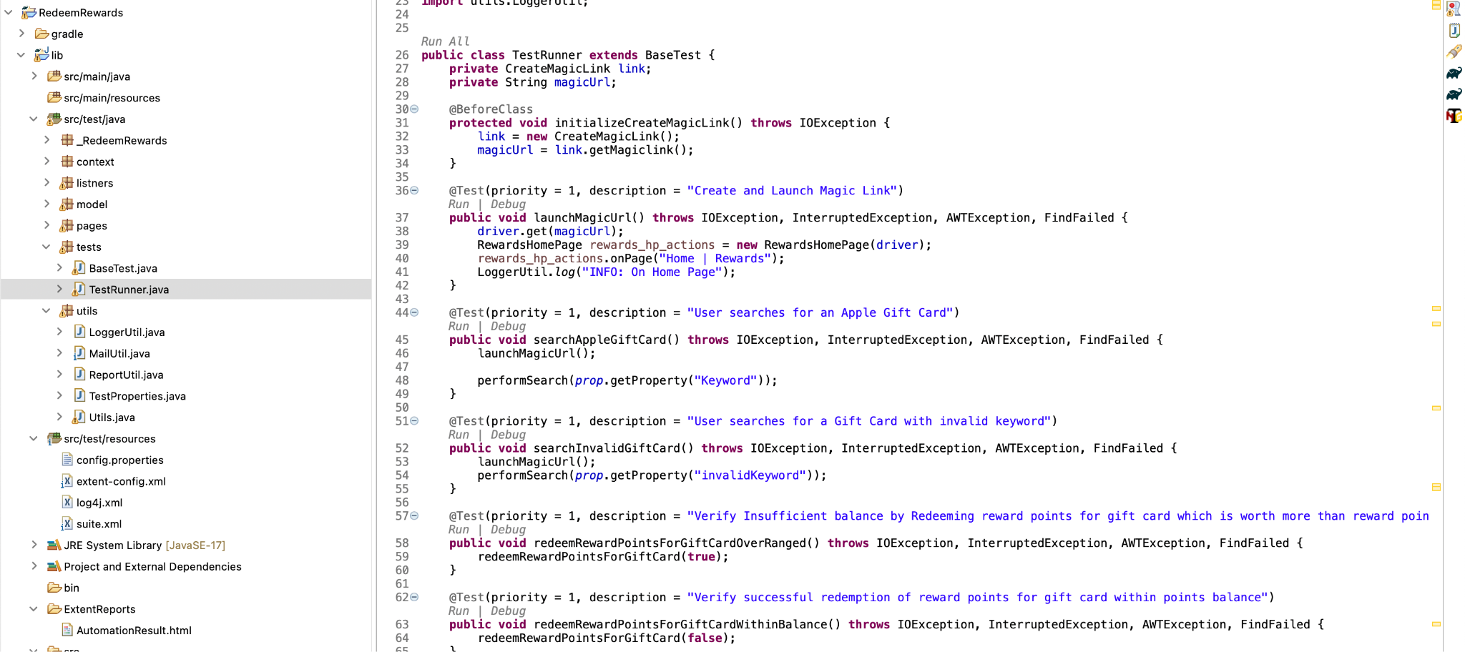**

**Path For Pages (To implement Page objects and Page methods):  
  
/lib/src/test/java/pages  
  
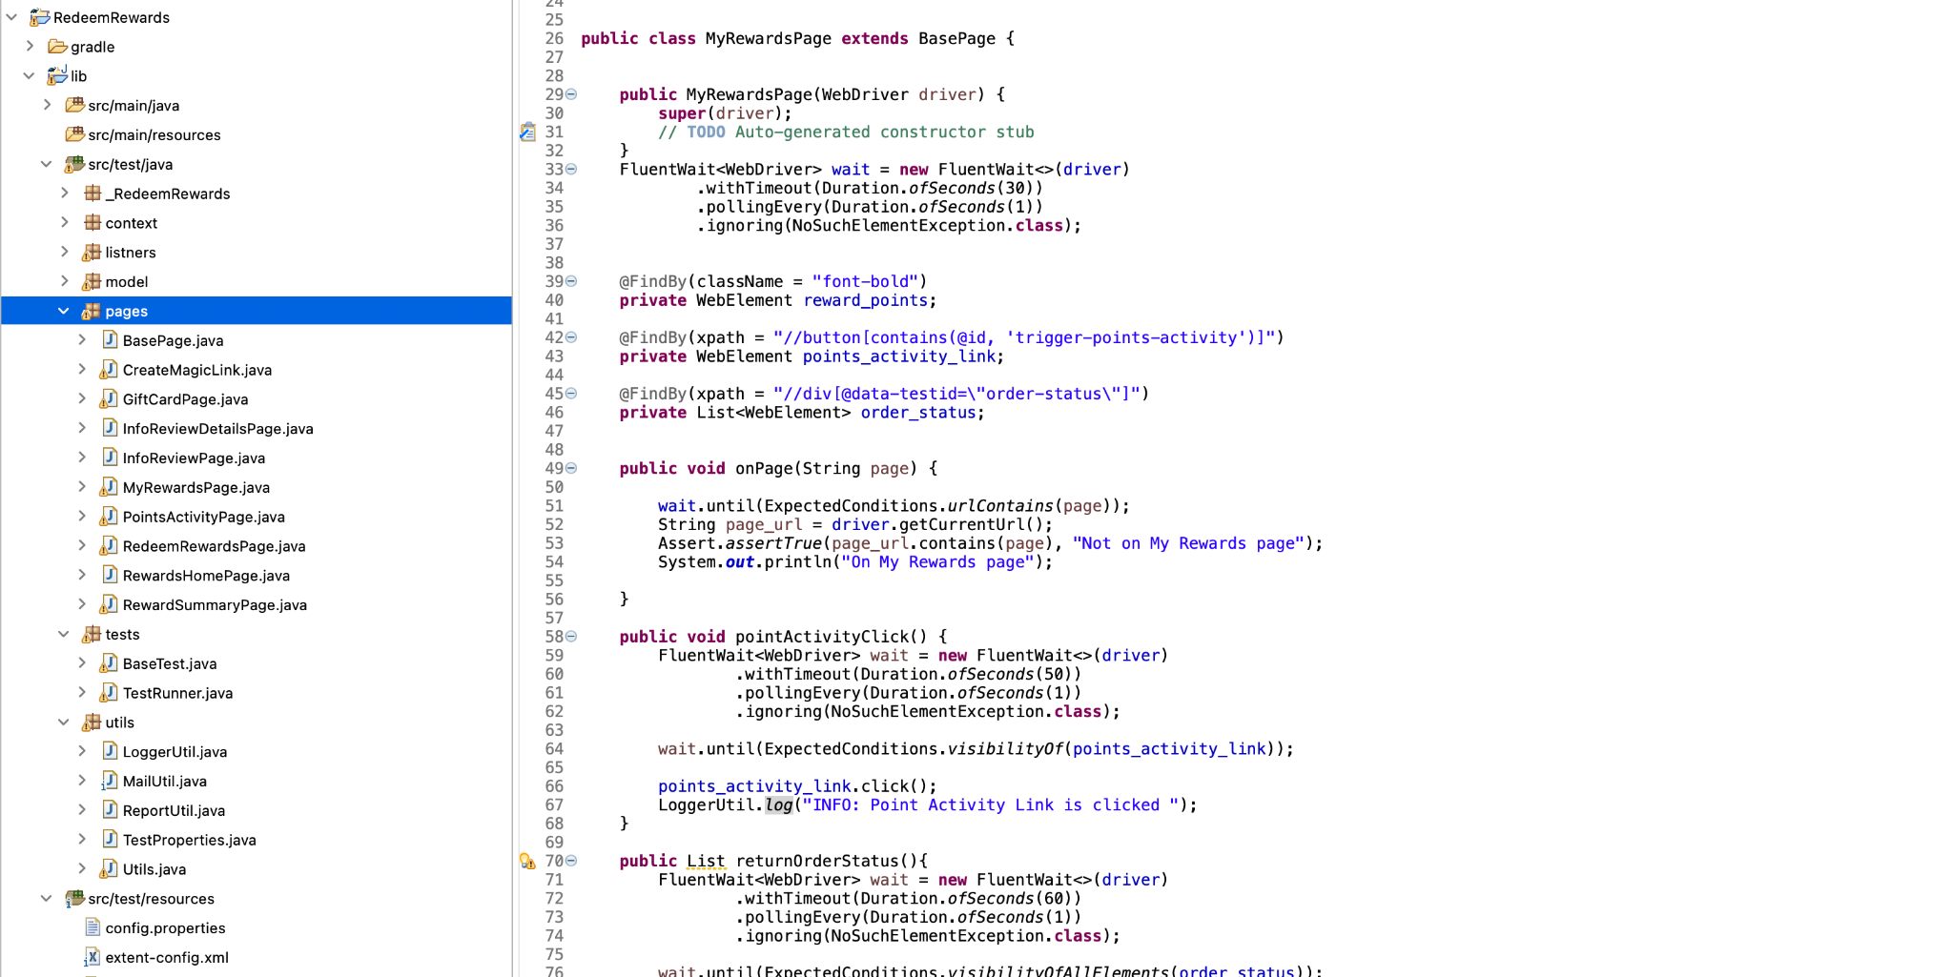**

**Path for JSON Object Model files to Make Request to API’s**

**/lib/src/test/java/model**

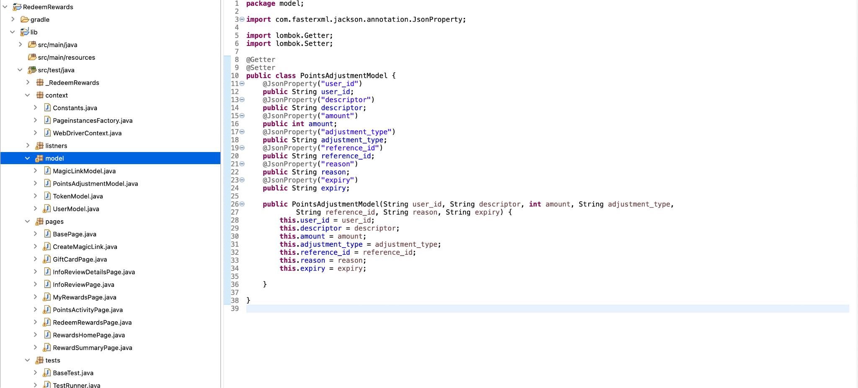

**Path To Utils Folder:**

**/lib/src/test/java/utils  
  
  
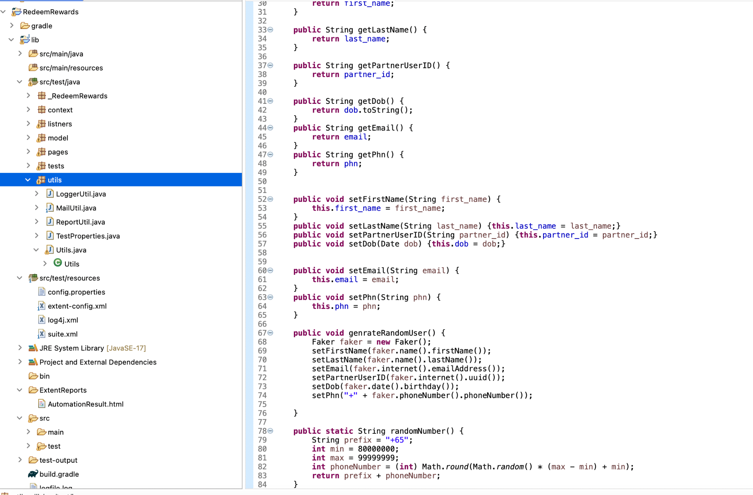**

**Path To pass the Test Data: (This Approach makes it easy for user to pass desired input to the test cases)**

**/lib/src/test/resources/config.properties  
  
  
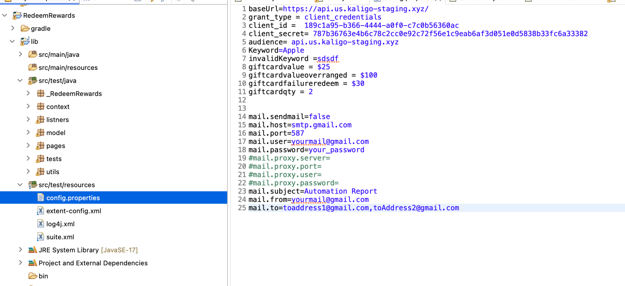**

**How to Run the Test Cases:**1. We are Running the test cases using TestNG

2. Path to Suit.xml : **/lib/src/test/resources/suite.xml**

3. Go to suit.xml file > uncomment the part of xml as provided in the comments in suit.xml file as per required execution > Right click on the file > RunAs > TestNG Suit  
  
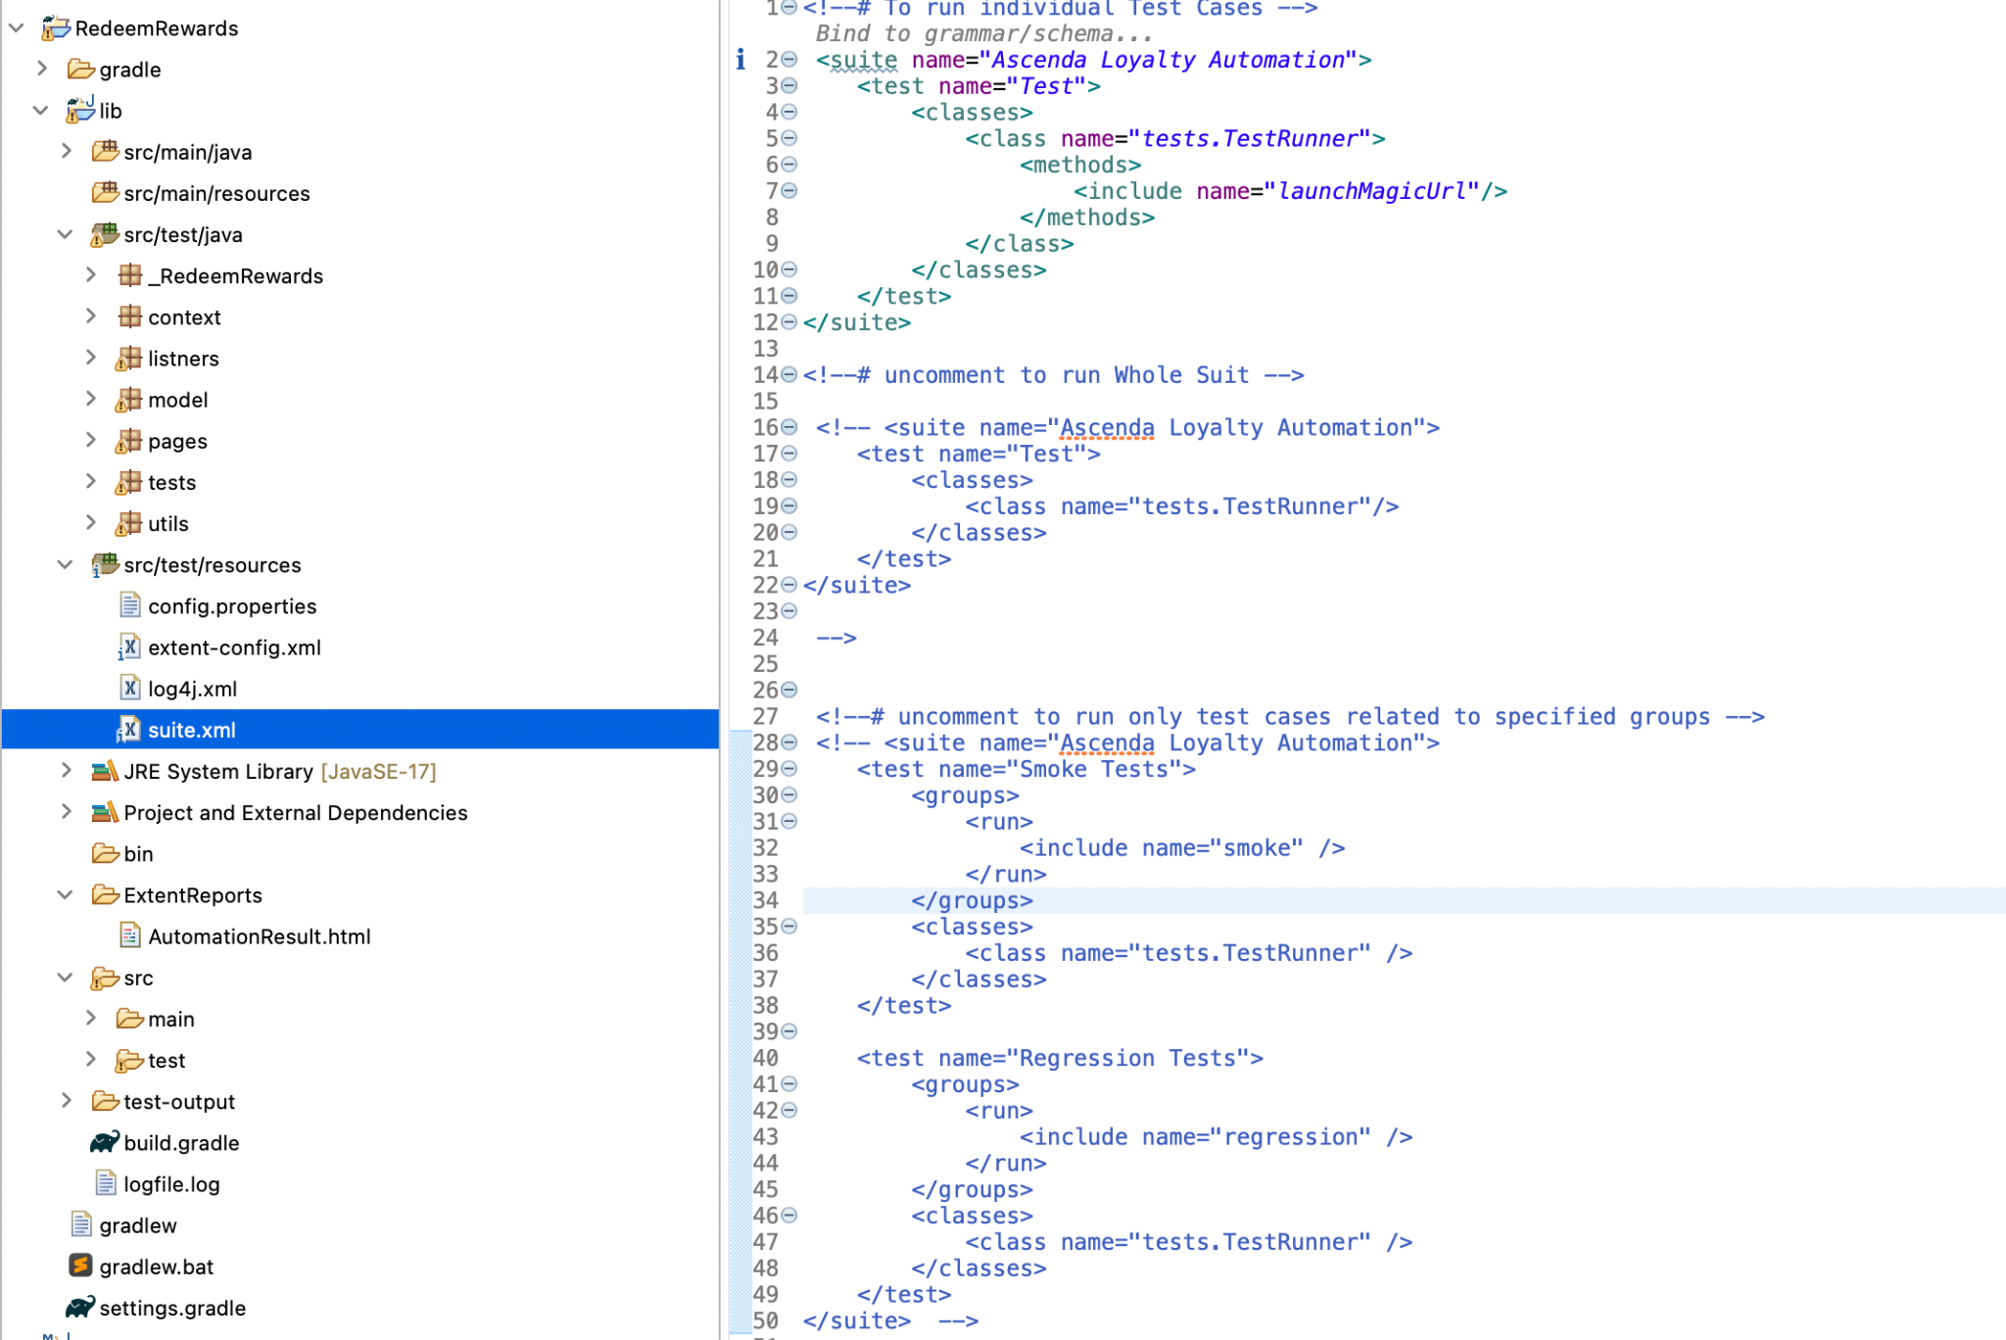

**Report generation:  
  
Using Extent reports to see the Test Results.**Path to Extent reports : **/lib/ExtentReports/AutomationResult.html**  
  
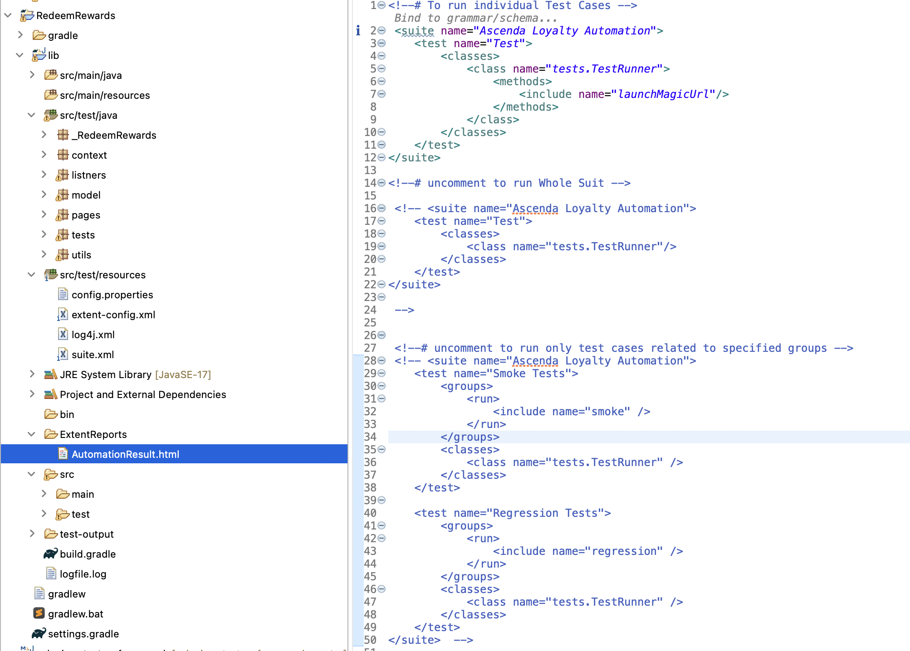

**View Log File**Excecution Log file Path : /lib/logfile.log  
  
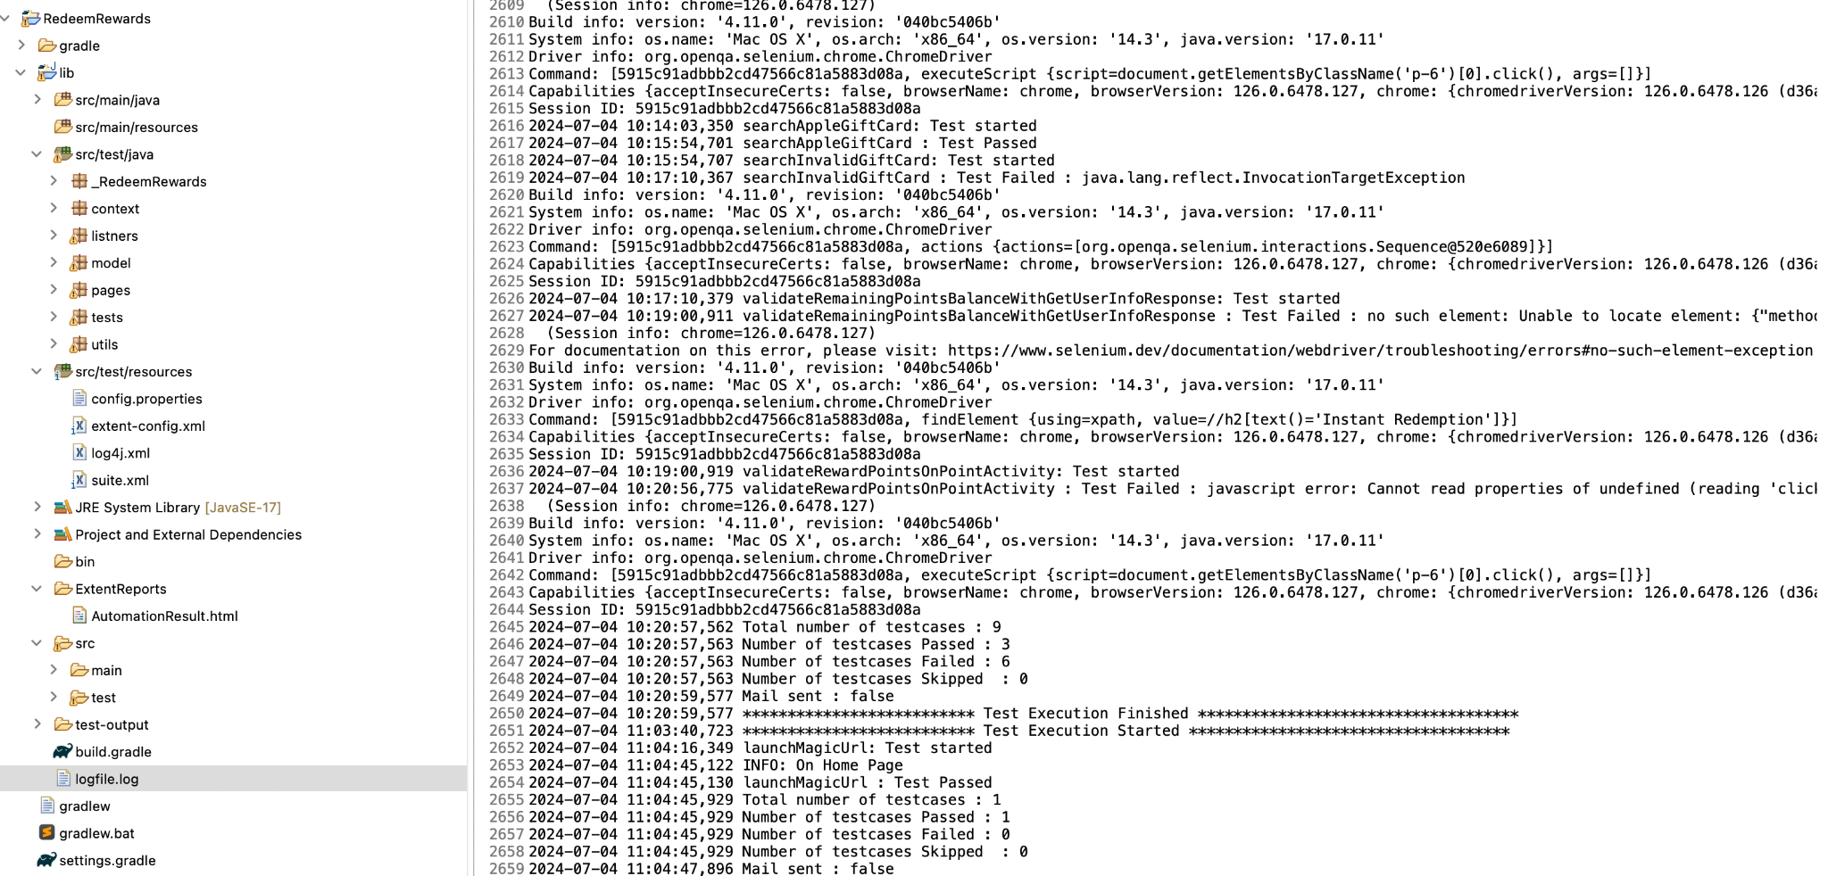

**Send ExecutionReport Email:**  
  
Can Provide required details in config.properties file and set mail.sendMail = “True” to receive mail for Executing the test cases.  
  
Path for emailable Report: **/lib/test-output/emailable-report.html**  
  
  
  
  
